**Report for Database Project**

**Morgan K. Thornton (Student ID: 03004063)**

**Jawad Adall**

**CSCI 432-01 Database Systems**

1. The ER diagram (with the attributes and foreign keys/primary keys indicated);

1. Write the commands for creating tables and inserting values;

SET SQL_MODE = "NO_AUTO_VALUE_ON_ZERO";

START TRANSACTION;

SET time_zone = "+00:00";

/*!40101 SET @OLD_CHARACTER_SET_CLIENT=@@CHARACTER_SET_CLIENT */;

/*!40101 SET @OLD_CHARACTER_SET_RESULTS=@@CHARACTER_SET_RESULTS */;

/*!40101 SET @OLD_COLLATION_CONNECTION=@@COLLATION_CONNECTION */;

/*!40101 SET NAMES utf8mb4 */;

CREATE DATABASE IF NOT EXISTS `grade_book` DEFAULT CHARACTER SET utf8mb4 COLLATE utf8mb4_general_ci;

USE `grade_book`;

DROP TABLE IF EXISTS `course`;

CREATE TABLE `course` (

`c_id` int(11) NOT NULL,

`lec_id` int(11) DEFAULT NULL,

`c_name` varchar(255) DEFAULT NULL,

`c_year` int(11) DEFAULT NULL,

`c_sem` varchar(255) DEFAULT NULL,

`c_weeks` int(11) DEFAULT NULL,

`c_participation_pts` int(11) DEFAULT NULL COMMENT 'Percentage of grade for participation',

`c_assignment_pts` int(11) DEFAULT NULL COMMENT 'Percentage of grade for assignments',

`c_project_pts` int(11) DEFAULT NULL COMMENT 'Percentage of grade for projects',

`c_exam_pts` int(11) DEFAULT NULL COMMENT 'Percentage of grade for exams',

`created_at` date DEFAULT NULL,

`updated_at` timestamp NOT NULL DEFAULT current_timestamp() ON UPDATE current_timestamp()

) ENGINE=InnoDB DEFAULT CHARSET=utf8mb4 COLLATE=utf8mb4_general_ci;

DROP TRIGGER IF EXISTS `total_check_before_insert`;

DELIMITER $$

CREATE TRIGGER `total_check_before_insert` BEFORE INSERT ON `course` FOR EACH ROW BEGIN

DECLARE total_marks integer;

DECLARE participation integer;

DECLARE assignment integer;

DECLARE project integer;

DECLARE exam integer;

SET participation = NEW.c_participation_pts;

SET assignment = NEW.c_assignment_pts;

SET project = NEW.c_project_pts;

SET exam = NEW.c_exam_pts;

SET total_marks = participation + assignment + project + exam;

IF total_marks < 100 THEN

SIGNAL SQLSTATE '45000'

SET MESSAGE_TEXT = 'All categories need to add upto exactly 100', MYSQL_ERRNO = 1001;

ELSEIF total_marks > 100 THEN

SIGNAL SQLSTATE '45000'

SET MESSAGE_TEXT = 'All categories need to add upto exactly 100', MYSQL_ERRNO = 1001;

END IF;

END

$$

DELIMITER ;

DROP TABLE IF EXISTS `course_coursework`;

CREATE TABLE `course_coursework` (

`cw_id` int(11) NOT NULL,

`cw_c_id` int(11) DEFAULT NULL,

`cw_course_type` enum('assignment','project','exam') DEFAULT NULL COMMENT 'Allowed types: project, assignment, exam',

`cw_content` text DEFAULT NULL COMMENT 'course work content',

`cw_release_date` date DEFAULT NULL,

`cw_due_date` date DEFAULT NULL,

`cw_total` int(11) DEFAULT 100,

`created_at` date DEFAULT NULL,

`updated_at` timestamp NOT NULL DEFAULT current_timestamp() ON UPDATE current_timestamp()

) ENGINE=InnoDB DEFAULT CHARSET=utf8mb4 COLLATE=utf8mb4_general_ci;

DROP TABLE IF EXISTS `course_participation`;

CREATE TABLE `course_participation` (

`cp_id` int(11) NOT NULL,

`cp_stc_id` int(11) DEFAULT NULL,

`cp_week` int(11) DEFAULT NULL,

`cp_present` tinyint(1) DEFAULT NULL,

`created_at` date DEFAULT NULL,

`updated_at` timestamp NOT NULL DEFAULT current_timestamp() ON UPDATE current_timestamp()

) ENGINE=InnoDB DEFAULT CHARSET=utf8mb4 COLLATE=utf8mb4_general_ci;

DROP TRIGGER IF EXISTS `ensure_participation_not_exceeded`;

DELIMITER $$

CREATE TRIGGER `ensure_participation_not_exceeded` BEFORE INSERT ON `course_participation` FOR EACH ROW BEGIN

DECLARE total_participation integer;

DECLARE total_weeks integer;

SET total_weeks = (SELECT course.c_weeks FROM student_courses

JOIN course ON student_courses.c_id = course.c_id WHERE student_courses.stc_id = NEW.cp_stc_id);

SET total_participation = (SELECT COUNT(cp_id) FROM course_participation WHERE cp_stc_id = NEW.cp_stc_id);

IF total_participation >= total_weeks THEN

SIGNAL SQLSTATE '45000'

SET MESSAGE_TEXT = 'You have reached the maximum number of attendances for this course';

END IF;

END

$$

DELIMITER ;

DROP TABLE IF EXISTS `lecturer`;

CREATE TABLE `lecturer` (

`lec_id` int(11) NOT NULL,

`lec_name` varchar(255) DEFAULT NULL,

`lec_gender` enum('male','female','other') DEFAULT NULL,

`lec_email` varchar(255) DEFAULT NULL,

`lec_phone` varchar(255) DEFAULT NULL,

`created_at` date DEFAULT NULL,

`updated_at` timestamp NOT NULL DEFAULT current_timestamp() ON UPDATE current_timestamp()

) ENGINE=InnoDB DEFAULT CHARSET=utf8mb4 COLLATE=utf8mb4_general_ci;

DROP TABLE IF EXISTS `student`;

CREATE TABLE `student` (

`st_id` int(11) NOT NULL,

`st_name` varchar(255) DEFAULT NULL,

`st_email` varchar(255) DEFAULT NULL,

`st_phone` varchar(255) DEFAULT NULL,

`st_gender` enum('male','female','other') DEFAULT NULL,

`created_at` date DEFAULT NULL,

`updated_at` timestamp NOT NULL DEFAULT current_timestamp() ON UPDATE current_timestamp()

) ENGINE=InnoDB DEFAULT CHARSET=utf8mb4 COLLATE=utf8mb4_general_ci;

DROP TABLE IF EXISTS `student_courses`;

CREATE TABLE `student_courses` (

`stc_id` int(11) NOT NULL,

`st_id` int(11) DEFAULT NULL,

`c_id` int(11) DEFAULT NULL,

`created_at` date DEFAULT NULL,

`updated_at` timestamp NOT NULL DEFAULT current_timestamp() ON UPDATE current_timestamp()

) ENGINE=InnoDB DEFAULT CHARSET=utf8mb4 COLLATE=utf8mb4_general_ci;

DROP TRIGGER IF EXISTS `ensure_no_duplicate_student_course`;

DELIMITER $$

CREATE TRIGGER `ensure_no_duplicate_student_course` BEFORE INSERT ON `student_courses` FOR EACH ROW BEGIN

DECLARE course_count integer;

SET course_count = (SELECT COUNT(stc_id) FROM student_courses WHERE st_id = NEW.st_id AND c_id = NEW.c_id);

IF course_count > 0 THEN

SIGNAL SQLSTATE '45000'

SET MESSAGE_TEXT = 'A student can enroll to a course once';

END IF;

END

$$

DELIMITER ;

DROP TABLE IF EXISTS `student_course_coursework`;

CREATE TABLE `student_course_coursework` (

`cw_id` int(11) NOT NULL,

`stc_id` int(11) NOT NULL,

`marks` int(11) DEFAULT NULL,

`created_at` date DEFAULT NULL,

`updated_at` timestamp NOT NULL DEFAULT current_timestamp() ON UPDATE current_timestamp()

) ENGINE=InnoDB DEFAULT CHARSET=utf8mb4 COLLATE=utf8mb4_general_ci;

ALTER TABLE `course`

ADD PRIMARY KEY (`c_id`),

ADD KEY `lec_id` (`lec_id`);

ALTER TABLE `course_coursework`

ADD PRIMARY KEY (`cw_id`),

ADD KEY `cw_c_id` (`cw_c_id`);

ALTER TABLE `course_participation`

ADD PRIMARY KEY (`cp_id`),

ADD KEY `cp_stc_id` (`cp_stc_id`);

ALTER TABLE `lecturer`

ADD PRIMARY KEY (`lec_id`);

ALTER TABLE `student`

ADD PRIMARY KEY (`st_id`);

ALTER TABLE `student_courses`

ADD PRIMARY KEY (`stc_id`),

ADD KEY `st_id` (`st_id`),

ADD KEY `c_id` (`c_id`);

ALTER TABLE `student_course_coursework`

ADD PRIMARY KEY (`cw_id`,`stc_id`),

ADD KEY `stc_id` (`stc_id`);

ALTER TABLE `course`

MODIFY `c_id` int(11) NOT NULL AUTO_INCREMENT;

ALTER TABLE `course_coursework`

MODIFY `cw_id` int(11) NOT NULL AUTO_INCREMENT;

ALTER TABLE `course_participation`

MODIFY `cp_id` int(11) NOT NULL AUTO_INCREMENT;

ALTER TABLE `lecturer`

MODIFY `lec_id` int(11) NOT NULL AUTO_INCREMENT;

ALTER TABLE `student`

MODIFY `st_id` int(11) NOT NULL AUTO_INCREMENT;

ALTER TABLE `student_courses`

MODIFY `stc_id` int(11) NOT NULL AUTO_INCREMENT;

ALTER TABLE `course`

ADD CONSTRAINT `course_ibfk_1` FOREIGN KEY (`lec_id`) REFERENCES `lecturer` (`lec_id`);

ALTER TABLE `course_coursework`

ADD CONSTRAINT `course_coursework_ibfk_1` FOREIGN KEY (`cw_c_id`) REFERENCES `course` (`c_id`);

ALTER TABLE `course_participation`

ADD CONSTRAINT `course_participation_ibfk_1` FOREIGN KEY (`cp_stc_id`) REFERENCES `student_courses` (`stc_id`);

ALTER TABLE `student_courses`

ADD CONSTRAINT `student_courses_ibfk_1` FOREIGN KEY (`st_id`) REFERENCES `student` (`st_id`),

ADD CONSTRAINT `student_courses_ibfk_2` FOREIGN KEY (`c_id`) REFERENCES `course` (`c_id`);

ALTER TABLE `student_course_coursework`

ADD CONSTRAINT `student_course_coursework_ibfk_1` FOREIGN KEY (`cw_id`) REFERENCES `course_coursework` (`cw_id`),

ADD CONSTRAINT `student_course_coursework_ibfk_2` FOREIGN KEY (`stc_id`) REFERENCES `student_courses` (`stc_id`);

COMMIT;

/*!40101 SET CHARACTER_SET_CLIENT=@OLD_CHARACTER_SET_CLIENT */;

/*!40101 SET CHARACTER_SET_RESULTS=@OLD_CHARACTER_SET_RESULTS */;

/*!40101 SET COLLATION_CONNECTION=@OLD_COLLATION_CONNECTION */;

1. Show the tables with the contents that you have inserted;

courses

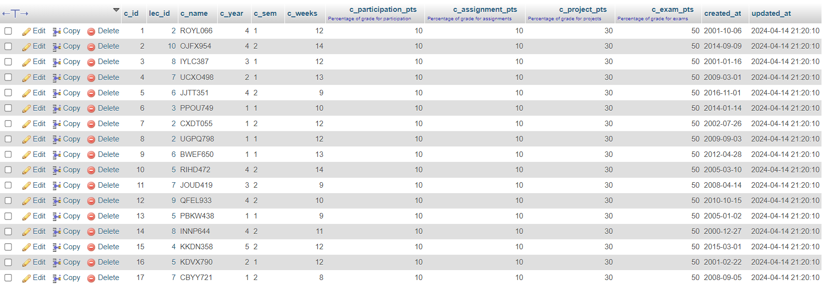

Course coursework (assignments, projects and exams)

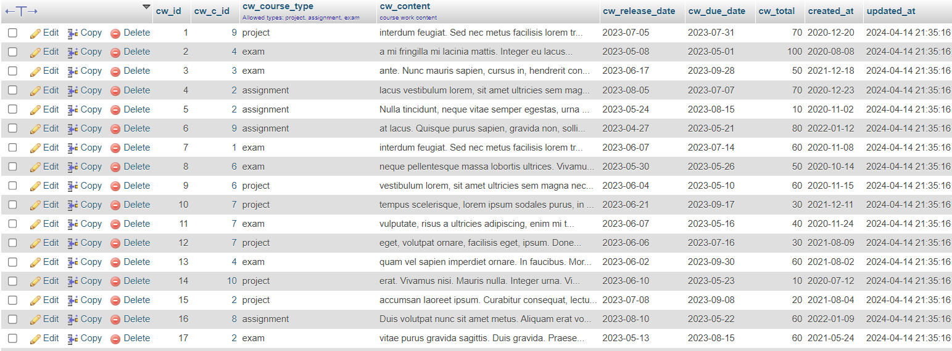

Lecturers

Students

Student courses

Student’s attempted coursework (student_course_coursework)

Course_participation (attendance history of students)

1. Compute the average/highest/lowest score of an assignment;

Code:

DELIMITER $$

CREATE DEFINER=`root`@`localhost` PROCEDURE `calculateMinMaxAve`(IN `assignment_id` INT)

BEGIN

DECLARE assignment_count integer;

DECLARE total_assignment integer;

DECLARE min_assignment integer;

DECLARE max_assignment integer;

DECLARE ave_assignment integer;

SET assignment_count = (SELECT COUNT(marks) FROM student_course_coursework WHERE cw_id = assignment_id);

SET total_assignment = (SELECT SUM(marks) FROM student_course_coursework WHERE cw_id = assignment_id);

SET @min_assignment = (SELECT MIN(marks) FROM student_course_coursework WHERE cw_id = assignment_id);

SET @max_assignment = (SELECT MAX(marks) FROM student_course_coursework WHERE cw_id = assignment_id);

SET @ave_assignment = total_assignment/assignment_count;

SELECT @ave_assignment AS `Average_Assignment_Score`, @min_assignment AS `Min_Assignment_Score`,@max_assignment AS `Max_Assignment_Score`;

END$$

DELIMITER ;

Test:

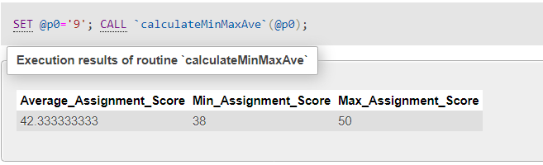

1. List all of the students in a given course;

Code:

BEGIN

SELECT student_courses.st_id AS id, student.st_name AS name, student.st_email AS email, @student.st_phone AS phone, student.st_gender AS gender FROM student_courses

INNER JOIN student on student_courses.st_id = student.st_id

WHERE student_courses.c_id = course_id;

END$$

Test:

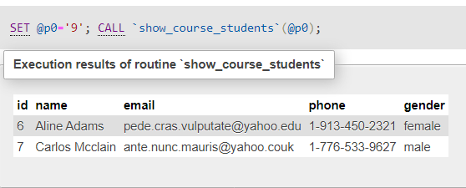

1. List all of the students in a course and all of their scores on every assignment;

Code:

select student.st_name, course.c_name, course_coursework.cw_id, course_coursework.cw_course_type, student_course_coursework.marks FROM student_course_coursework

JOIN course_coursework ON student_course_coursework.cw_id = course_coursework.cw_id

JOIN student_courses ON student_course_coursework.stc_id = student_courses.stc_id

JOIN student ON student_courses.st_id = student.st_id

JOIN course ON student_courses.c_id = course.c_id

WHERE course.c_id = 6 GROUP BY student.st_name;

Test (course id = 6):

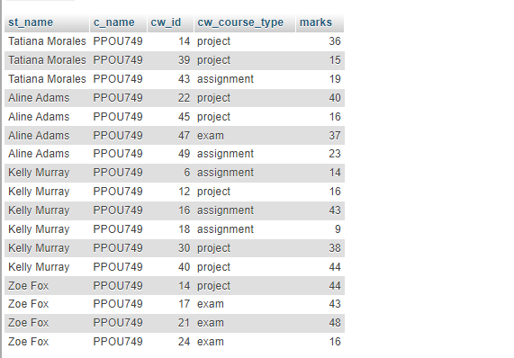

1. Add an assignment to a course;

Code:

INSERT INTO course_coursework (cw_id,cw_c_id,cw_course_type,cw_content,cw_release_date,cw_due_date,cw_total,created_at)

VALUES(NULL, 10, 'assignment', 'fsdhfihosdifghdfgivibsidbgibidfbgdibibfaifdbidsbfvsibgidnifdniobnifdbgsdiobgdoibgioboibgdiobgdifbg','2024-04-03','2024-04-10',50,'2024-03-21');

Test:

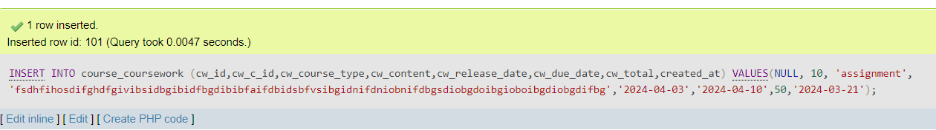



1. Change the percentages of the categories for a course;

Code:

UPDATE `course` SET `c_participation_pts`=20,`c_assignment_pts`=20,`c_project_pts`=20,`c_exam_pts`=40 WHERE `c_id` = 11;

Test:

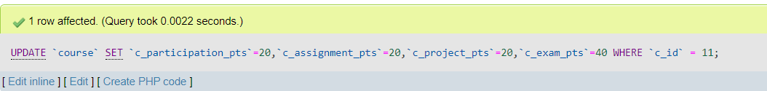



1. Add 2 points to the score of each student on an assignment;

Code:

BEGIN

DECLARE total_score integer;

SET total_score = (SELECT cw_total FROM course_coursework WHERE cw_id = assignment_id);

UPDATE student_course_coursework SET marks = (

CASE WHEN (marks + points) <= total_score THEN (marks + points)

WHEN (marks + points) > total_score THEN (marks + (points - ((points + marks)- total_score)))

END)

WHERE cw_id = assignment_id;

END

Test:



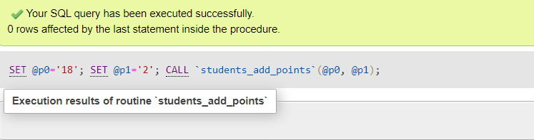

1. Add 2 points just to those students whose last name contains a ‘Q’.

Code:

DELIMITER $$

CREATE DEFINER=`root`@`localhost` PROCEDURE `students_add_points_q`(IN `assignment_id` INT, IN `points` INT)

BEGIN

DECLARE total_score integer;

SET total_score = (SELECT cw_total FROM course_coursework WHERE cw_id = assignment_id);

UPDATE student_course_coursework

JOIN student_courses ON student_course_coursework.stc_id = student_courses.stc_id

JOIN student ON student_courses.st_id = student.st_id

SET student_course_coursework.marks = (

CASE WHEN (student_course_coursework.marks + points) <= total_score THEN (student_course_coursework.marks + points)

WHEN (student_course_coursework.marks + points) > total_score THEN (student_course_coursework.marks + (points - ((points + student_course_coursework.marks)- total_score)))

ELSE (student_course_coursework.marks + points)

END)

WHERE student_course_coursework.cw_id = assignment_id AND student.st_name LIKE '%q%';

END$$

DELIMITER ;

Test: (No change expected since no student’s name starts with q

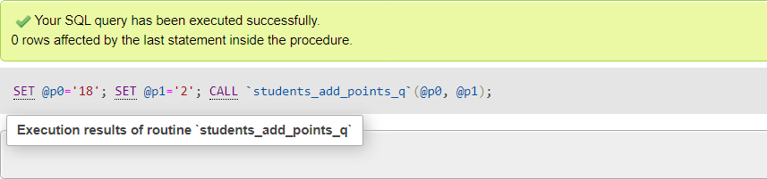

1. Compute the grade for a student;

Code:

BEGIN

DECLARE participation_count integer;

DECLARE participation_present integer;

DECLARE participation_g_total integer;

DECLARE participation_pct integer;

DECLARE assignment_pct integer;

DECLARE project_pct integer;

DECLARE exam_pct integer;

DECLARE assignment_grade decimal(10,1);

DECLARE project_grade decimal(10,1);

DECLARE exam_grade decimal(10,1);

DECLARE student_grade decimal(10,1);

SET participation_count = (SELECT c_weeks FROM course WHERE c_id = course_id);

SET participation_pct = (SELECT c_participation_pts FROM course WHERE c_id = course_id);

SET assignment_pct = (SELECT c_assignment_pts FROM course WHERE c_id = course_id);

SET project_pct = (SELECT c_project_pts FROM course WHERE c_id = course_id);

SET exam_pct = (SELECT c_exam_pts FROM course WHERE c_id = course_id);

SET participation_present = (SELECT COUNT(cp_id) FROM course_participation

JOIN student_courses ON course_participation.cp_stc_id = student_courses.stc_id

JOIN student ON student_courses.st_id = student.st_id

JOIN course ON student_courses.c_id = course.c_id

WHERE student.st_id = student_id AND course.c_id = course_id AND cp_present = TRUE);

SET @participation_g_total = ((participation_present/participation_count)*100)*(participation_pct/100);

SET @assignment_grade = (calculate_category_grade(student_id, course_id, 'assignment', assignment_pct));

SET @project_grade = (calculate_category_grade(student_id, course_id, 'project', project_pct));

SET @exam_grade = (calculate_category_grade(student_id, course_id, 'exam', exam_pct));

SET @student_grade = (@participation_g_total + @assignment_grade + @project_grade + @exam_grade);

SELECT @participation_g_total AS Participation, @assignment_grade AS Assignments, @project_grade AS Projects, @exam_grade AS Exams, @student_grade AS Student_Grade;

END

Calculate_category_grade function:

BEGIN

DECLARE done integer DEFAULT FALSE;

DECLARE cw_total integer;

DECLARE cw_id integer;

DECLARE cw_marks integer;

DECLARE cw_grade decimal(10,1);

DECLARE cur1 CURSOR FOR SELECT cw_id, cw_total FROM course_coursework WHERE cw_c_id = course_id AND cw_course_type = type;

DECLARE CONTINUE HANDLER FOR NOT FOUND SET done = TRUE;

SET @cw_grade = 0.00;

OPEN cur1;

cw_loop: LOOP

FETCH cur1 INTO cw_id, cw_total;

IF done THEN

LEAVE cw_loop;

END IF;

SET cw_marks = ( SELECT marks FROM student_course_coursework

JOIN student_courses ON student_course_coursework.stc_id = student_courses.stc_id

JOIN student ON student_courses.st_id = student.st_id

WHERE student_course_coursework.cw_id = cw_id AND student.st_id = student_id);

IF cw_marks IS NOT NULL THEN

SET @cw_grade = cw_grade + (((cw_marks/cw_total)*100)*(grade_pct/100));

END IF;

END LOOP;

CLOSE cur1;

RETURN @cw_grade;

END

Test:

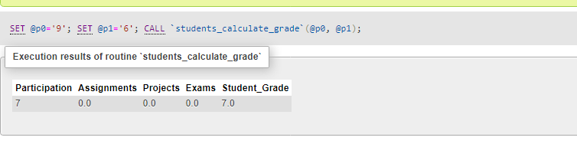

(student id: 9 and course id: 6)

1. Compute the grade for a student, where the lowest score for a given category is dropped

Code:

DELIMITER $$

CREATE DEFINER=`root`@`localhost` PROCEDURE `students_calculate_grade_minus_min`(IN `student_id` INT, IN `course_id` INT)

BEGIN

DECLARE participation_count integer;

DECLARE participation_present integer;

DECLARE participation_g_total integer;

DECLARE participation_pct integer;

DECLARE assignment_pct integer;

DECLARE project_pct integer;

DECLARE exam_pct integer;

DECLARE assignment_grade decimal(10,1);

DECLARE project_grade decimal(10,1);

DECLARE exam_grade decimal(10,1);

DECLARE student_grade decimal(10,1);

SET participation_count = (SELECT c_weeks FROM course WHERE c_id = course_id);

SET participation_pct = (SELECT c_participation_pts FROM course WHERE c_id = course_id);

SET assignment_pct = (SELECT c_assignment_pts FROM course WHERE c_id = course_id);

SET project_pct = (SELECT c_project_pts FROM course WHERE c_id = course_id);

SET exam_pct = (SELECT c_exam_pts FROM course WHERE c_id = course_id);

SET participation_present = (SELECT COUNT(cp_id) FROM course_participation

JOIN student_courses ON course_participation.cp_stc_id = student_courses.stc_id

JOIN student ON student_courses.st_id = student.st_id

JOIN course ON student_courses.c_id = course.c_id

WHERE student.st_id = student_id AND course.c_id = course_id AND cp_present = TRUE);

SET @participation_g_total = ((participation_present/participation_count)*100)*(participation_pct/100);

SET @assignment_grade = (calculate_category_grade_minus_min(student_id, course_id, 'assignment', assignment_pct));

SET @project_grade = (calculate_category_grade_minus_min(student_id, course_id, 'project', project_pct));

SET @exam_grade = (calculate_category_grade_minus_min(student_id, course_id, 'exam', exam_pct));

SET @student_grade = (@participation_g_total + @assignment_grade + @project_grade + @exam_grade);

SELECT @participation_g_total AS Participation, @assignment_grade AS Assignments, @project_grade AS Projects, @exam_grade AS Exams, @student_grade AS Student_Grade;

END$$

DELIMITER ;

calculate_category_grade_minus_min function:

DELIMITER $$

CREATE DEFINER=`root`@`localhost` FUNCTION `calculate_category_grade_minus_min`(`course_id` INT, `type` VARCHAR(50), `student_id` INT, `grade_pct` INT) RETURNS decimal(10,1)

BEGIN

DECLARE done integer DEFAULT FALSE;

DECLARE cw_total integer;

DECLARE cw_id integer;

DECLARE cw_marks integer;

DECLARE cw_grade decimal(10,1);

DECLARE min_score decimal(10,1);

DECLARE grade_score decimal(10,1);

DECLARE cur1 CURSOR FOR SELECT cw_id, cw_total FROM course_coursework WHERE cw_c_id = course_id AND cw_course_type = type;

DECLARE CONTINUE HANDLER FOR NOT FOUND SET done = TRUE;

SET grade_score = 0.0;

SET min_score = 0.0;

OPEN cur1;

cw_loop: LOOP

FETCH cur1 INTO cw_id, cw_total;

IF done THEN

LEAVE cw_loop;

END IF;

SET cw_marks = (SELECT marks FROM student_course_coursework

JOIN student_courses ON student_course_coursework.stc_id = student_courses.stc_id

JOIN student ON student_courses.st_id = student.st_id

WHERE student_course_coursework.cw_id = cw_id AND student.st_id = student_id);

IF cw_marks IS NOT NULL THEN

SET cw_grade = ((cw_marks/cw_total)*100)*(grade_pct/100);

IF min_score = 0.0 THEN

SET min_score = cw_grade;

SET grade_score = grade_score + cw_grade;

ELSEIF min_score > cw_grade THEN

SET min_score = cw_grade;

END IF;

SET grade_score = grade_score + cw_grade;

END IF;

END LOOP;

CLOSE cur1;

SET grade_score = grade_score - min_score;

RETURN grade_score;

END$$

DELIMITER ;

Test:

